

TOMS Monitoring System

Table of Contents
Table of Contents 2
Terms used in this document 3
Purpose 3
Background 3
Target Audience 3
Users guide 4
Location 4
Default page – Real Time Status 4
Report options 5
Trace Route Report 6
Host Outages 7
Tool tips 8
Support Information 9
Development Tools 9
Host Requirements 9
Testing 9
Overview 9
Database Tables 10
Database permissions 10
Source Code 10
TOMSMonitor Web site 11
Location 11
Files 11
Configuration 11
TOMSMonitor Executable 12
Location 12
Schedule 12
User Account 12
Configuration 12
Monitor.ini 12
SQLServerName 12
SQLUserName 12
TOMSEmail 12
DefaultTimeout 12
EmailTOMSOutages 13
Screenshot 14

Terms used in this document

TOMS | Total Offender Management System
TOMS Server | A Sun Cluster used to host the TOMS Application

Purpose

This document should be used to gain an understanding of the design, features, and capabilities of the TOMS Monitoring system and also to configure and maintain the TOMS Monitoring system.

Background

TOMS is a Visual BASIC application whose function is the management of Prisoners. Offender Management staff within the Department of Justice use this application.

AIMS is a private firm whose main role for the Department of Justice is the handling of Prisoners during transport, as well as the management of Western Australia’s only private Prison – Acacia Prison.

Because of the distance between the TOMS application Server and Acacia Prison, WAN Links are involved. These links, like any other WAN may, from time to time become unavailable, or become overly congested. These problems may prevent the TOMS application from accessing the TOMS Server, and thus making the system unavailable.

The TOMS Monitoring system has been designed to monitor, and optionally report on outages of the TOMS System as viewed by consumers of the TOMS data. Technology used to perform this function includes:

Custom Win32 Executable file
Custom Win32 Active X Object
Microsoft Active Server Pages
Microsoft Data Engine

Target Audience

This document is divided into two sections.

Section 1, the Users Guide is general information for all users.
Section 2, Support Information is more specific information intended for Support and Administration staff.

Users guide

Location

The URL for access to the site is http://TOMSMonitor.

Default page – Real Time Status

A screen similar to the following will be displayed.

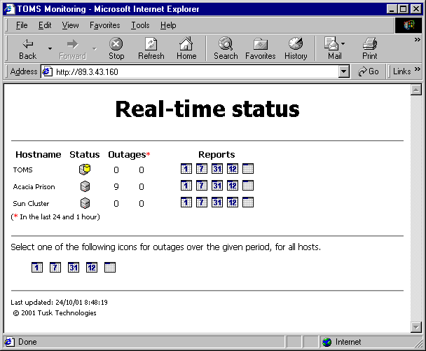

In this screenshot, there are 9 outages for the Acacia Prison, but none in the last hour. TOMS and the Sun Cluster have had no outages.

To view information on these nine outages, click on one of the report graphics.

The images are explained in the following section.

Report options

- Daily Schedule – outages in the last 24 hours
- Weekly Schedule – outages in the last 7 days
- Monthly Schedule – outages in the last month
- Yearly Schedule – outages in the last twelve months
- All – All outages

Outages in the last 24 hours
Outages in the last 7 days
Outages in the last month
Outages in the last 12 months
All Outages

Trace Route Report

Each report will display a report over the required period for the specified host. An example screenshot of the daily report is displayed below.

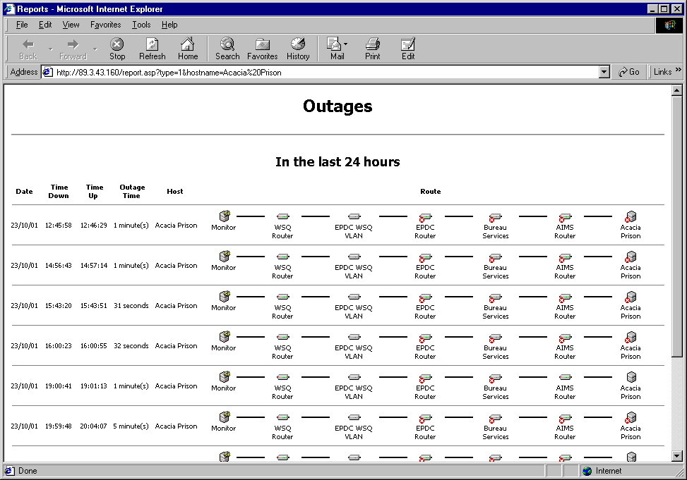

This page shows each host along the route to the appropriate destination host.

- The image shows that the host was not contactable within the default timeout period (specified in monitor.ini).

- This page may be used to determine where any particular outage was.

- The names under each image may be modified by editing the tblRouteNames table in the database.

If there are no outages in the period specified, this is displayed by a report similar to the following:

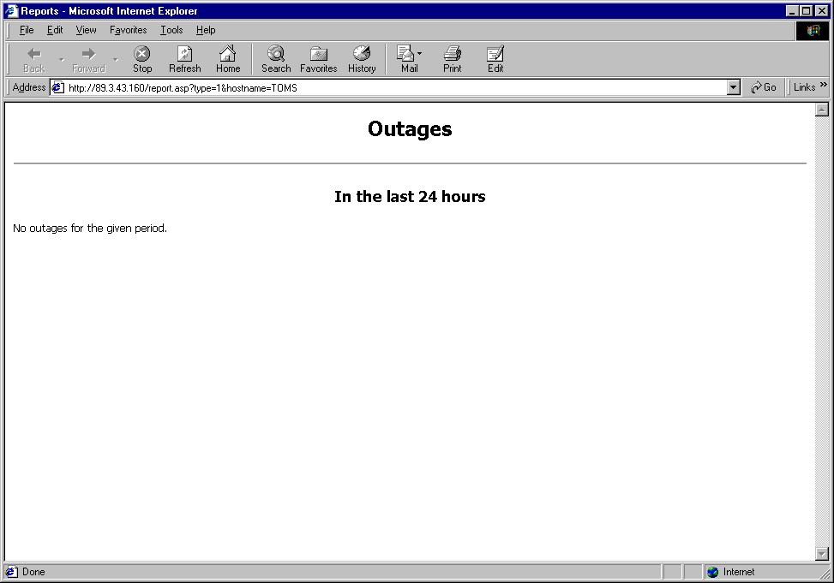

Host Outages

When an outage occurs, this is displayed in the Default page as follows.

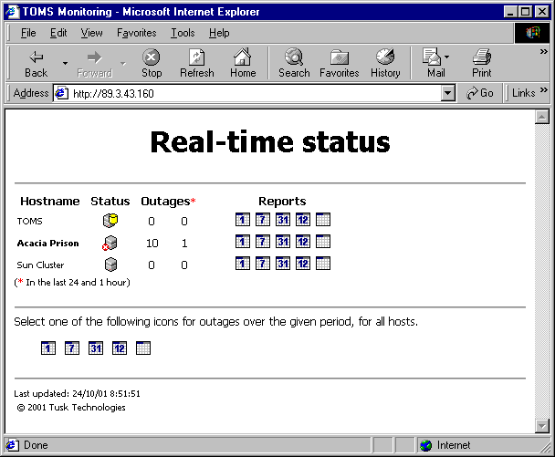

Tool tips

Most images use the alt tag to display information on the function of the particular image.

The following shows one such tool tip.

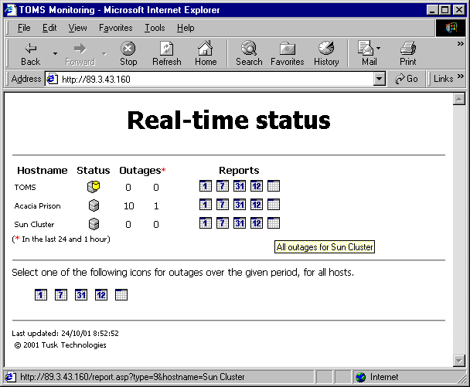

Support Information

Development Tools

Applications used in the development of the TOMS Monitoring System were:

- Microsoft Visual BASIC 6.0 Enterprise Edition (Service Pack 5);
- Allaire Homesite (Version 4.5.2);
- Microsoft Data Engine (Service Pack 2).

Host Requirements

- Microsoft Data Engine (MSDE)
- Visual BASIC Runtime files
- mswinsck.ocx
- drping.ocx
- Windows NT/2000
- SMTP Service (for email capabilities) - optional
- IIS 4.0, IIS 5.0 or PWS
- Scheduled Tasks Service (NOT the Windows NT Task Scheduler)

Testing

The TOMS Monitoring System has been tested and is compatible with the following platforms:

- Microsoft Windows NT 4 Workstation (Service Pack 6)*;
- Microsoft Windows NT 4 Server (Service Pack 6);
- Microsoft Windows 2000 Professional (Service Pack 1);
- Microsoft Windows 2000 Professional (Service Pack 2);
- Microsoft Internet Explorer 5.x and 6.0 for the web pages.

* Note that email capabilities are not available on NT4 Workstation due to the inability to install the SMTP Service

Overview

The TOMS Monitoring application (TOMSMonitor.exe) performs the following tasks:

- Monitor changes in the state of the TOMS Server (via a routine that performs in a similar fashion to the Oracle tnsping utility) – every 30 seconds;
- Ping each host specified, looking for changes in state – 30 seconds after the previous cycle was completed;
- Any outage (and subsequent availability) is emailed to selected email addresses (if enabled).
- The web page is automatically refreshed every 30 seconds by a HTTP META-REFRESH tag.

NOTE: A maximum of 10 hosts may be monitored by TOMSMonitor.exe. This is by design.

Database Tables

Table Name | Fields | Example | Table Usage
tblEmail | ID  Address | 1  fred.bloggs@justice.wa.gov.au | Contains the list of email addresses which may be used as addressees in the event of a change in state of a host.
tblErrors | ID  Time  Source  Number  Description | 1  23/10/2001 15:23:00  tmrPing_Timer  9  Subscript out of range | Contains all runtime errors that occur during normal processing. This is for debugging only.
tblEvents | ID  Time  HostID  Event | 1  23/10/2001 15:23:00  8  up | All events (either up or down) are contained here.
tblHosts | ID  Name  IP  isUp  Time  Timeout  EmailID | 1  Acacia Prison  10.45.30.1  1  23/10/2001 15:23:00  200  0 | Host information is stored here.  isUp is either 1 or 0, indicating whether the Host was last contactable or not.  Time refers to the last time connection was attempted to this host.  Timeout is the time in Milliseconds to wait for a ping reply.
tblRoute | ID  HostID  Path | 20  8  89.3.4.1,89.20.252.34 | Path refers to the route used to contact the Host in the event of an outage.
tblRouteNames | ID  IP  Name | 1  10.45.254.74  AIMS Router | Contains the friendly names for each IP address listed in any route.
tblTOMS | ID  Time  Event | 1  23/10/2001 15:23:00  ok | TOMS Server events are listed here.
tblTrace | ID  EventID  Result | 210  3390  89.3.4.1:1,89.20.252.34:0 | This is the results of a ‘trace route’ to a host in the form IP:state,IP:State

Database permissions

The IIS Anonymous Account (IUSR_<ServerName>) must be given SELECT rights to each table in the database. Failure to allow this will necessitate the usage of Global Groups, or individual SQL Server database users. Failure to also do this will cause the web site to be non functional.

Source Code

All source code and web files remain the property of Tusk Technologies.

TOMSMonitor Web site

Location
The following picture illustrates the file locations for the TOMS web files

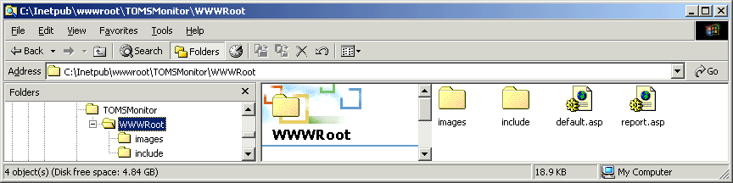

Files

The following is a list of all files required for correct operation of the web site.

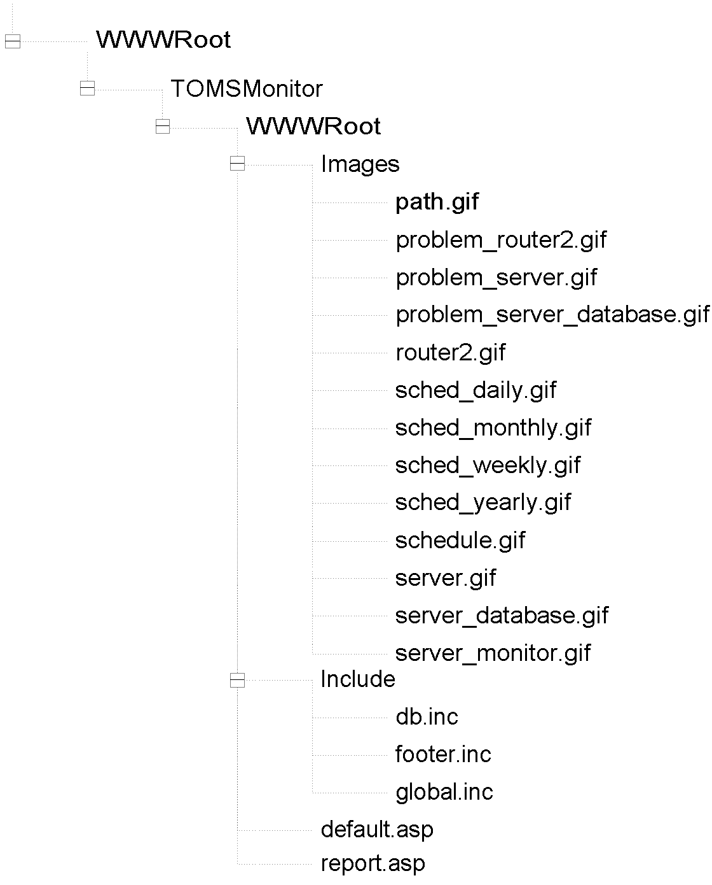

Configuration

The web site is configured as the Default site inside Internet Services Manager.
This ensures easy access to the site with a single URL (i.e. http://TOMSMonitor).

Anonymous access is enabled via the use of the IUSR_<ServerName> account.

TOMSMonitor Executable

Location

The Win32 executable TOMSMonitor.exe is hosted by the same computer as the web site and Database server, and is ‘installed’ at c:\TOMSMonitor\TOMSMonitor.exe. This location is not crucial.

Schedule

The application is configured to run “When my computer starts” using the Scheduled Tasks service.

User Account

A local user (username = Monitor, password= <blank>, Group Membership= Administrators) is used as the account to run the application. The account name used is not crucial.

Configuration

Configuration of the executable is performed through either the database (as mentioned previously), or with the monitor.ini file. This file must be located in the same directory as the executable.

Monitor.ini

[Setup]
SQLServerName=(Local)
SQLUserName = sa
TOMSEmail=helpdesk@justice.wa.gov.au
DefaultTimeout=3000
EmailTOMSOutages=0

SQLServerName
refers to the SQL Server used to host the database. (Local) is used by default.

SQLUserName
refers to the SQL Server user account used to access the database. The password is always assumed to be blank.

TOMSEmail
the email address to use to send TOMS outage messages to, i.e. the email recipient.

DefaultTimeout
the time (in milliseconds) to wait for each reply when performing a trace route operation.

EmailTOMSOutages
the setting that controls whether to send email when TOMS outages occur. To not send emails, or when the SMTP service is not installed, use 0, otherwise use 1.

Screenshot

